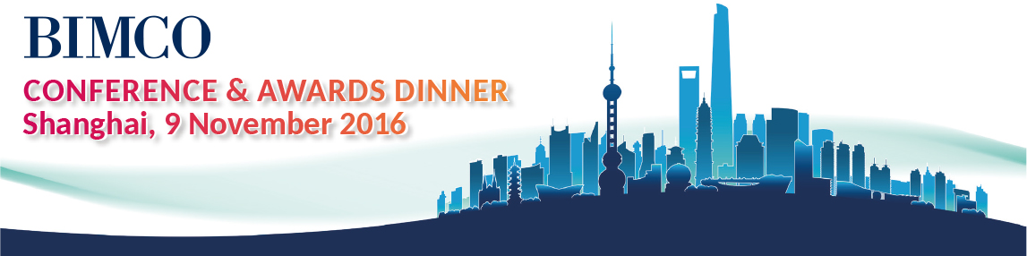

INVITATION LETTER 邀请函
Date  时间 | November 9, 2016  2016年11月9日
Venue  地点 | Ritz-Carlton Shanghai Pudong  上海浦东丽思卡尔顿酒店
Fees  (excl. VAT)  费用  （不含税） | EUR 210 for BIMCO Members  BIMCO会员：210欧元
EUR 275 for Non-members
非会员：275欧元
Content  内容 | Unique insight from leading global shipping CEOs on shipping’s road to market recovery – and what’s affecting their business today  从全球航运顶级CEO对航运复兴之路和影响因素的交流中获取独到的见解
 | Key Speakers  部分  演讲嘉宾 | Philippe Louis-Dreyfus (Louis Dreyfus Armateurs)  菲利普·路易德雷福斯，BIMCO主席
Xu Lirong (China COSCO Shipping Corporation Ltd)
许立荣，中国船东协会主席&中远海运集团董事长
Sabrina Chao (Chairman of HKSOA and Wah Kwong Shipping)
赵式明，香港船东协会主席&华光海运（香港）有限公司董事长
Sun Licheng (Chairman of CCS and of IACS)
孙立成，中国船级社总裁&IACS主席
Tim Smith (Chairman of Maersk China, and Chief Maersk Group Representative for North Asia)
施敏夫，马士基（中国）有限公司董事长&马士基集团北亚区首席代表
Bill Guo (Executive Director of ICBC Leasing)
郭芳萌，工银租赁执行总经理
Wang Dawei (General Manager of Shandong Shipping Corporation)
王大为，山东海运总经理
Networking with leading shipping professionals at BIMCO’s special reception
参与BIMCO举办的鸡尾酒会与航运精英深度交流
Celebration of shipping companies and individuals who have excelled in key areas at BIMCO’s Awards Dinner
亲临BIMCO本年度颁奖盛典
Find out more online or register now.

